SQL ASSIGNMENT -4

ROLL NO-84016

Q1.Write a select command that produces the order number , amount,and date for all rows in the Orders table.
Ans.
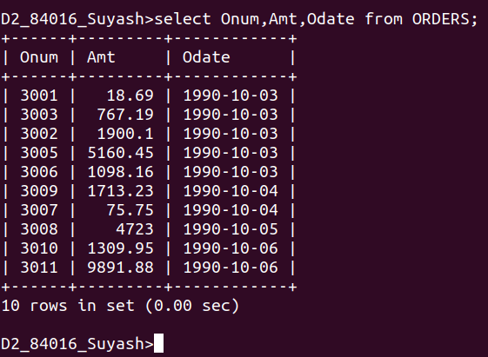

Q2.Write a query that produces all rows from the Customers table for which the salesperson’s number is 1001.
Ans.
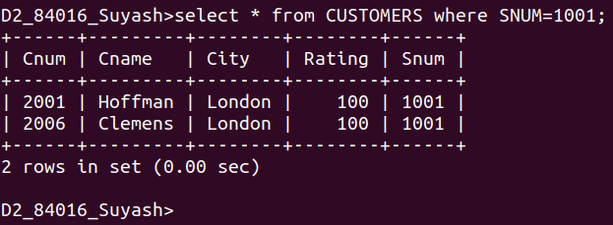

Q3.Write a query that displays the Salespeople table with the columns in the following order:city ,sname,snum,comm.
Ans.
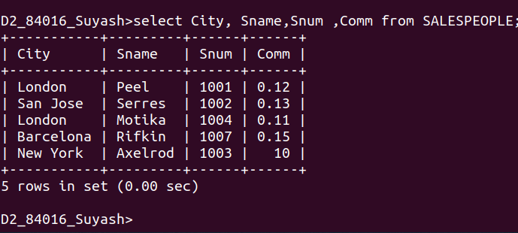

Q4.Write a select command that produces the rating followed by the name of each customer in san jose.
Ans.
